**Repository structure**

Repository contains the following:\

* ./terraform - Terraform configuration for the EKS cluster running in AWS.
* ./kube - All the configurations required for the application running in Kubernetes cluster.
* ./docs - Directory which contains overview of the components.

Docs are:

* [deployment](https://bitbucket.org/ls_server/aws-infrastructure/src/0a594614bf6a88b0bcadf28bb6508d8e0efc2485/docs/1-deployment.md) - Document which is describing process of cluster installation.
* [AWS resources overview](https://bitbucket.org/ls_server/aws-infrastructure/src/0a594614bf6a88b0bcadf28bb6508d8e0efc2485/docs/2-aws-resources-overview.md) - AWS resources which are used for the deployment and Terraform configurations description
* [Kubernetes resources overview](https://bitbucket.org/ls_server/aws-infrastructure/src/0a594614bf6a88b0bcadf28bb6508d8e0efc2485/docs/3-kubernetes-resources-overview.md) - Overview of used Kubernetes resources.
* [Kubernetes software](https://bitbucket.org/ls_server/aws-infrastructure/src/0a594614bf6a88b0bcadf28bb6508d8e0efc2485/docs/4-software-components-overview.md) - Doc which is describing all software components which are installed in the cluster.
* [Usage](https://bitbucket.org/ls_server/aws-infrastructure/src/0a594614bf6a88b0bcadf28bb6508d8e0efc2485/docs/5-usage.md) - Contains cheatsheet of commands for daily usage of cluster.

**Network**

Development

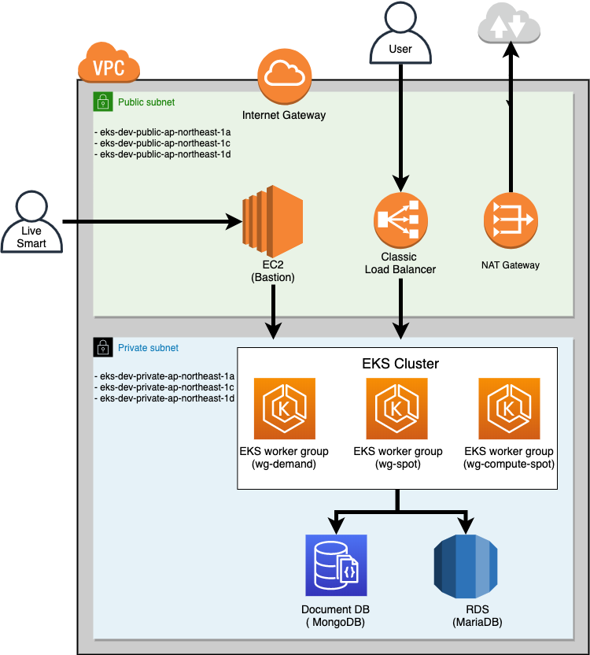

VPC

| **Name** | **CIDR** |
| --- | --- |
| eks-dev | 10.0.0.0/16 |

Subnets

| **Name** | **Type** | **CIDR** |
| --- | --- | --- |
| eks-dev-private-ap-northeast-1a | Private | 10.0.1.0/24 |
| eks-dev-private-ap-northeast-1c | Private | 10.0.2.0/24 |
| eks-dev-private-ap-northeast-1d | Private | 10.0.3.0/24 |
| eks-dev-public-ap-northeast-1a | Public | 10.0.4.0/24 |
| eks-dev-public-ap-northeast-1c | Public | 10.0.5.0/24 |
| eks-dev-public-ap-northeast-1d | Public | 10.0.6.0/24 |